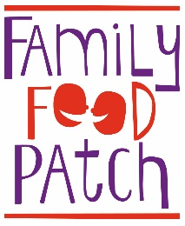

Family Food Patch Educator training

Expression of Interest (EOI) Form

Our Family Food Patch training takes place over six weekly sessions looking at topics such as introducing solids, lunchboxes, getting children involved, drinks, label reading, fussy eating and active play.

Places for our Family Food Educator training sessions are limited. To register your interest in joining a training please complete the information below and post or email back to me. Your details will be held on our EOI register and successful applicants will be notified at least 4 weeks prior to training starting.
Name: ____________
Mailing Address: ____________
Phone: ____________
Email: ____________
Why are you interested in becoming a Family Food Educator? ____________________________________
________________________
Do you have children/grandchildren? If yes, how old are they? ____________
Which topics particularly interest you? ____________________________________
__________________
Which community groups or child/family-based organisations, if any, are you currently a member of?
________________________
Where did you hear about the course? ______________
How far are you able to travel for a training course? ______
Please return to: Family Food Patch, PO Box 689, North Hobart, TAS 7002
or email: emma@familiestasmania.org.au
If you need any other information or you would prefer to lodge your application over the phone, please don’t hesitate to call me: 0438 926 242
Many thanks, Emma

