Youth, Family and Community Connections Employment Programs
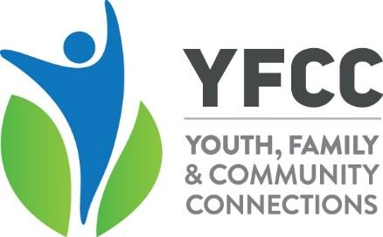
Fit For Work Project Devonport - Tayla - Mob: 0436 462 476 E:taylas@yfcc.com.au
Burnie - Calita - Mob: 0432 571 173 E:calitab@yfcc.com.au
Fit for Work is a project funded by Jobs Tasmania. The project works with local Job Service agencies in the Devonport and Burnie regions to identify young jobseekers (aged between 16 and 25 years) who need additional supports to enter the workforce. Two full-time project workers work intensively with participants for 6 to 12 months to address health and wellbeing issues, build relationships and social connections and participate in soft employment skills training. The project aims to support participants to rebuild their health, confidence and lost social capital, so they are more likely to secure meaningful employment and become independent of welfare support.
Youth Pathways Program Shae - Mob: 0448 281 240 E:shaep@yfcc.com.au
The Youth Pathways Program is delivered in partnership with Burnie Works Ltd, providing support to young people aged 16 to 25 to access one-to-one support of a Youth Coach during their initial period of employment. The program aims to ensure young people remain in employment and any issues arising during their probationary period are promptly addressed to ensure their maximum potential for maintaining their employment.

Project Detour Karen - Mob: 0466 413 254 E:karenm@yfcc.com.au
Mel - Mob: 0466 413 159 E:melaniew@yfcc.com.au
Christina - Mob: 0460 632 688 E:christinar@yfcc.com.au
Project Detour is a 2-year project funded by the Australian Government through the Safer Communities Fund. The project works with young people (aged between 16 and 24 years) who identify as being impacted by crime and/or anti-social behaviours and may be at risk of becoming entrenched in the criminal justice system. Full-time project workers work intensively with participants for 6 to 12 months to address health and wellbeing issues, build relationships and social connections and participate in soft employment skills training. The project aims to support participants to become engaged in youth tailored training, education and employment, as well as providing coaching to improve psychosocial outcomes.
Career Connector Service Leanne - Mob: 0466 508 557 E:leannec@yfcc.com.au
The Career Connector Service is a 3-year project funded by Jobs Tasmania. The service aims to support specific population groups to reengage with work and/or formal education and training by providing skills assessment, careers coaching, employment advice, and referrals to employers and relevant service providers.
The specific population groups are:
- people who have lost employment or have been made redundant in the last 12 months (including assisting applications to the Jobs Tasmania Rapid Response Skills Initiative)
- young people 18-25 years
- older Tasmanians aged 45+ years who have been out of the workforce for 12 months or more
- Migrants who have been residing in Tasmania for more than six months, have working rights and are unemployed or under employed.
Job seekers from these four groups will be taken through an initial intake process that will identify and record their current situation, goals and career aspirations, work readiness and any barriers to seeking/accessing education, training and/or employment.

Telephone: (03) 6423 6635 Email: reception@yfcc.com.au Website: www.yfcc.com.au

